**Overview：**

In a complete fermentation engineering experiment, real-time monitoring of key metabolic products (such as *lysine* and *glucose*) is essential for effective process control and optimization. During the three-day fermentation cycle, samples are collected and analyzed every four hours to determine the concentration of the target metabolites.

Traditional methods rely on manual operations, including sampling, filtration, dilution, and mixing with buffer solutions, followed by enzyme electrode measurements. This process is labor-intensive, complex, and difficult to automate, making continuous monitoring and precise process regulation challenging.

To address these limitations, we designed and constructed a low-cost, fully automated system for scheduled sampling and concentration analysis based on an ESP32 microcontroller. The system can automatically and quantitatively sample from the fermenter according to a predefined program, perform on-line filtration and dilution, and deliver the processed sample to a detection chamber equipped with enzyme electrodes for concentration measurement.

All measurement data are transmitted in real time via Wi-Fi to a local server, where users can remotely configure system parameters, visualize real-time data, and download historical records through a web interface. This design enables the digitalized and unmanned monitoring of the fermentation process, laying the foundation for intelligent bioprocess control.

**Method：**

**1. Hardware Design and Implementation**

**1.1 Hardware Architecture**

The automatic quantitative sampling device consists of three main hardware modules:

①Main control and communication module: Responsible for coordinating fluidic operations, processing sensor data, and communicating with the local server.

②Fluidic processing module: Enables quantitative sampling, dilution, and mixing of the sample with buffer solution through precise flow control.

③Sensor processing module: Supports accurate sampling within the quantitative loop and real-time reading of analyte concentrations via enzyme electrodes.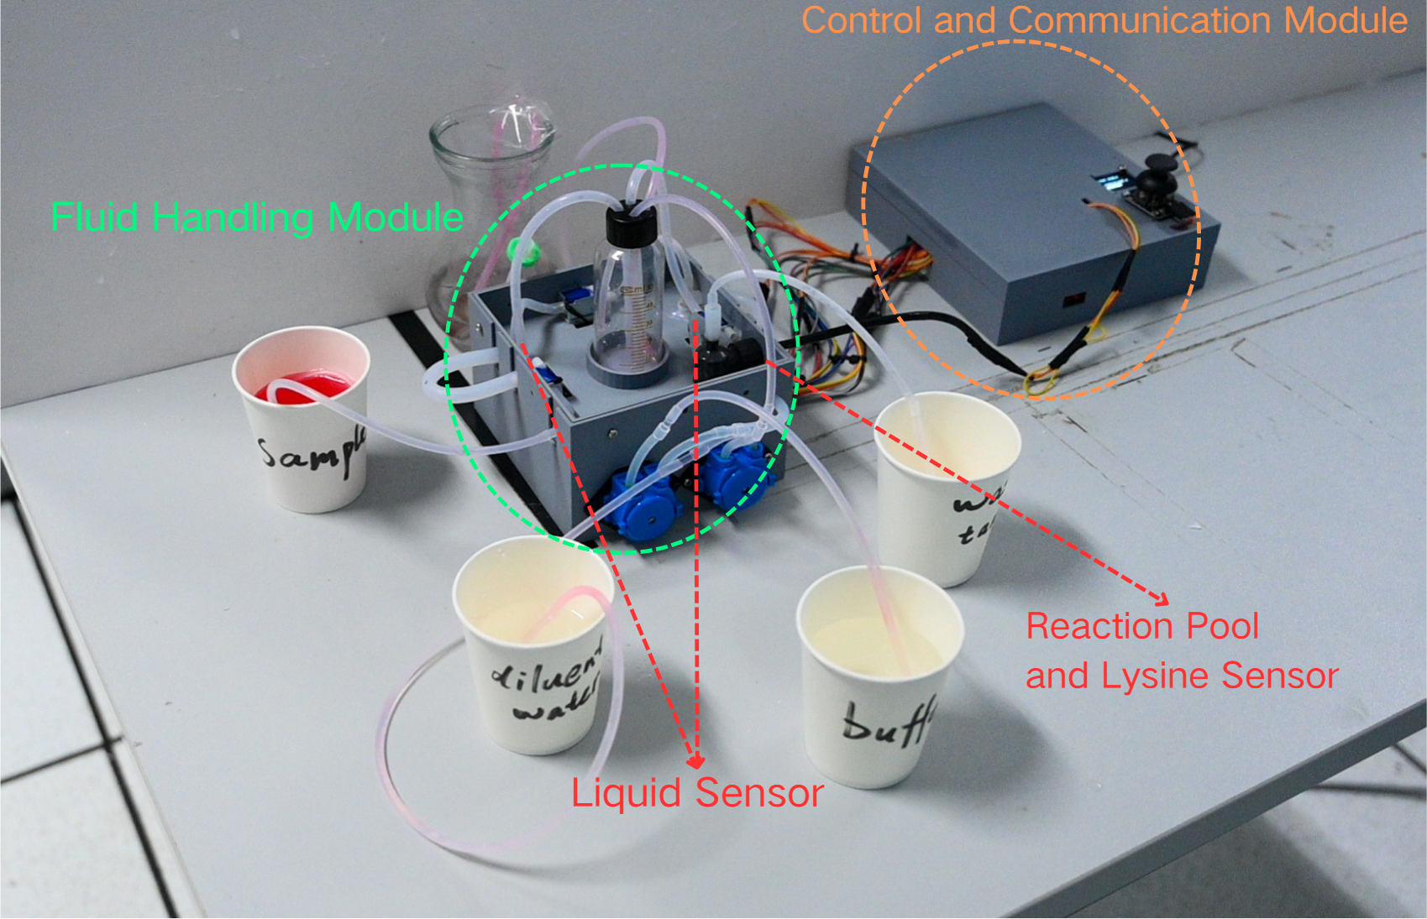

Figure 1, Hardware Design Diagram

**1.2 Main Control and Communication Module (ESP32, Wi-Fi)**

The system is centered on an ESP32 microcontroller, which utilizes its high-performance dual-core processor to coordinate peripheral devices such as peristaltic pumps and solenoid valves, achieving precise timing and sequence control. The built-in analog-to-digital converter (ADC) enables direct acquisition of multiple sensor signals for real-time monitoring.

For communication, a Wi-Fi–based wireless solution is implemented, allowing flexible deployment and seamless integration into local area networks. The ESP32 transmits processed data to a local server in real time while simultaneously hosting an embedded web server. Users can access the interface via a standard web browser to configure operational parameters, visualize live data, and monitor system status remotely.

This design ensures fully automated control and real-time remote supervision of the sampling and concentration analysis process, significantly enhancing the system’s adaptability and scalability in bioprocess monitoring applications.

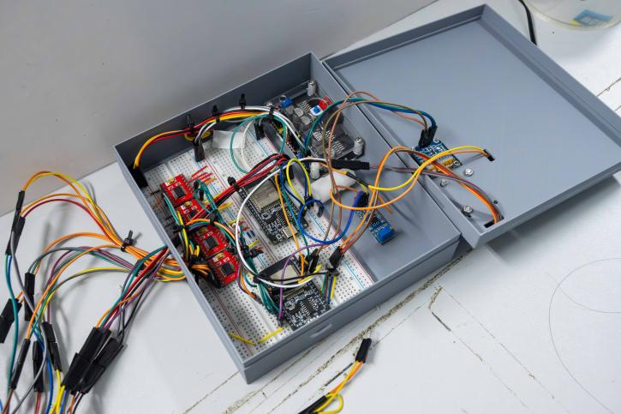

Figure 2, Physical Image of the Control Module 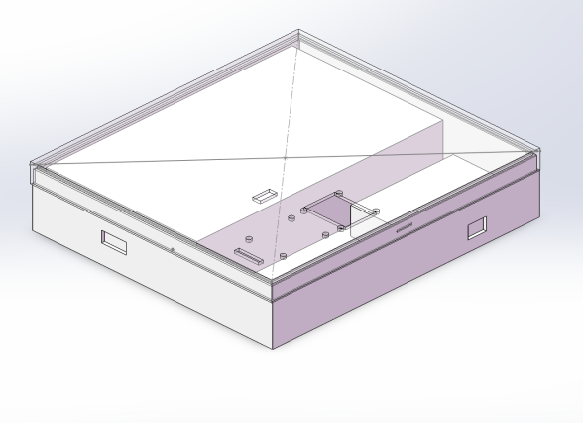

Figure 3, Model of the Control Module

**1.3 Fluidic Processing Module**

**1.3.1 Quantitative Sampling and Dilution Device**

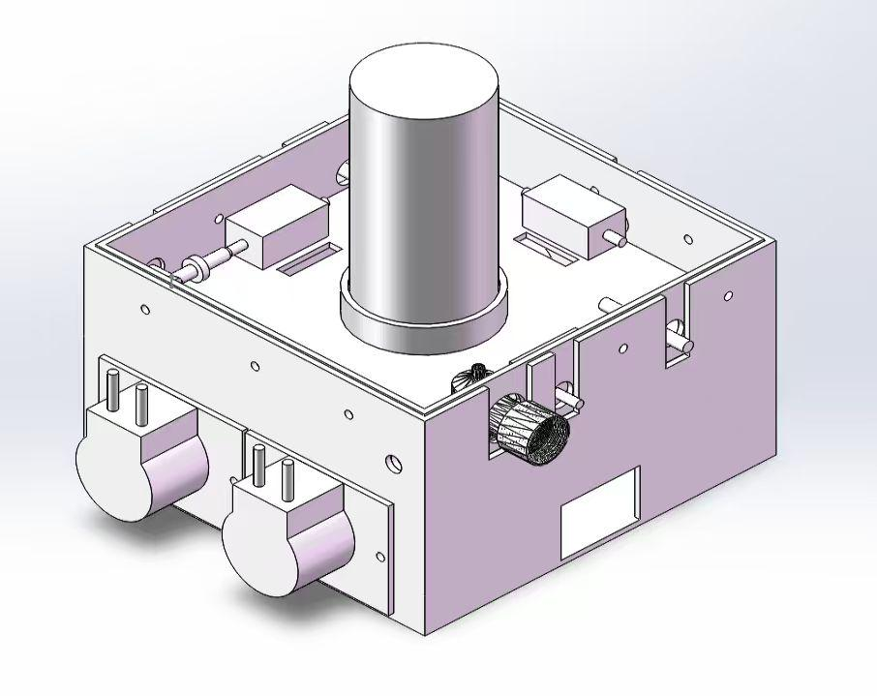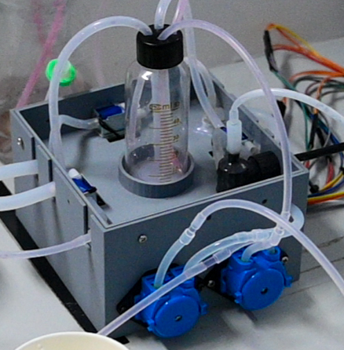

Figure 4, Physical Image of the Fluid Handling Module

Figure 5, Model of the Fluid Handling Module

**1）Design Objectives and Functional Requirements**

In the co-fermentation process of lysine and cadaverine, achieving real-time and accurate monitoring of key metabolic product concentrations is essential for enhancing experimental precision and optimizing fermentation performance. The primary metabolites involved in the system — glucose, lysine, and succinate — exhibit dynamic concentration changes that directly influence product yield and the formation of by-products.

However, conventional detection methods rely on manual sampling, sample dilution, and chemical or chromatographic analyses, which are labor-intensive and time-consuming. These limitations make it impossible to achieve direct, automated, and real-time monitoring within the fermenter.

To address this challenge, the present project aims to develop a high-efficiency, reliable automatic sampling device. The system is designed to:

1. Automatically collect fermentation samples at predefined time intervals or under specific process conditions;
2. Perform automated dilution according to the expected concentration ranges of different metabolites;
3. Ensure high precision and reproducibility throughout the sampling process;
4. Minimize manual intervention to realize fully autonomous online monitoring.

By integrating these capabilities, the device will significantly improve the reliability and temporal resolution of metabolic data acquisition, providing a robust foundation for subsequent process optimization, dynamic regulation, and data-driven control of the fermentation system.

**2）Device Design**

We developed an automated system integrating quantitative sampling and dilution functionalities to enable online monitoring of target metabolite concentrations. The apparatus is constructed using peristaltic pumps, multi-port solenoid valves, and an ultrafiltration membrane, providing capabilities for sampling, filtration, precise quantification, dilution, and cleaning.

The operational workflow is as follows: the peristaltic pump withdraws fermentation broth, which passes through the ultrafiltration membrane to remove microbial cells and particulate impurities before entering the quantitative loop. Upon detection of a full liquid level by the integrated sensor, the system automatically actuates the valves, transferring the sample into the dilution chamber to complete quantitative sampling. Subsequently, sterile water is introduced for dilution, and sterile air is applied to ensure thorough mixing. The diluted sample is then re-quantified in the loop and conveyed by the peristaltic pump to the analytical module for measurement.

To ensure continuity and reproducibility of operations, the system incorporates an automated cleaning protocol: residual liquid in the dilution chamber is rapidly discharged after each sampling cycle, and the chamber walls are flushed with clean water, effectively preventing cross-contamination.

**Device Features**

The system integrates **online filtration, quantitative sampling, and automated dilution units**, offering the following advantages:

1. The sampling and dilution processes are **precisely controllable**, ensuring high **data consistency**;
2. The **ultrafiltration membrane** effectively removes microbial cells and impurities, enhancing **detection accuracy**;
3. Equipped with **automatic liquid discharge and cleaning mechanisms**, facilitating **repeated use**;
4. The overall design is **compact and highly automated**, making it suitable for **continuous online sampling and analysis** during fermentation processes in laboratory settings.

Figure 2, Overall Device Diagram

**1.3.2 Reaction and Measurement Chamber Design**

After obtaining the diluted sample, accurate detection of the target metabolite concentrations is required. Enzyme electrode sensors necessitate thorough mixing of the sample with buffer solution to ensure stable electrochemical signals and measurement accuracy. Therefore, the system incorporates a dedicated reaction chamber capable of both accommodating the enzyme sensor and achieving efficient liquid-phase mixing.

The chamber is fabricated in-house using 3D printing with waterproof materials, providing good corrosion resistance and sealing performance. The bottom of the chamber features two independent inlets for the introduction of diluted sample and buffer solution, ensuring controlled and uniform fluid entry, while the top includes a discharge outlet for efficient removal of waste liquid.

On the side of the chamber, a concentration sensor based on enzyme membrane decomposition principles is installed to process the sample and measure the electrical signal in real time, thereby obtaining metabolite concentration information. Additionally, a magnetic stirring system is integrated at the bottom of the chamber to promote efficient mixing of the sample and buffer during measurement, ensuring the stability and reliability of sensor readings.

This design not only enables precise handling and measurement of the sample but also provides a key hardware foundation for automated online monitoring, making it broadly applicable for dynamic monitoring and process optimization of target metabolites during fermentation.

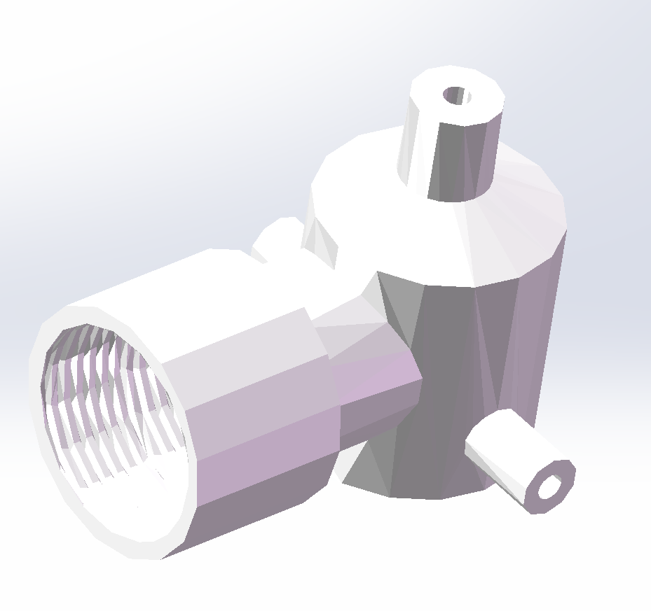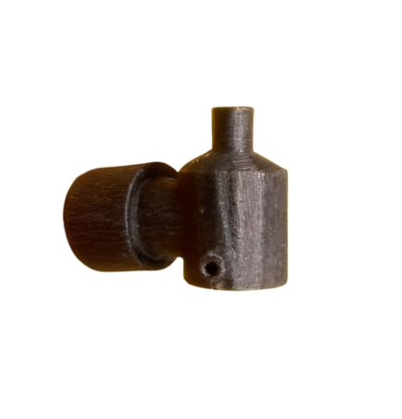

Figure 7, Model of the Reactor Figure 6, Physical Image of the Reactor

**1.3.3 Fluidic Characteristics and Mixing Performance of the Reaction Chamber**

Through fluid dynamics simulations and related experiments, the inlet and outlet channel layout, as well as the coupling between the stirring and sensing components, were optimized to achieve a balance between mass transfer efficiency and flow field stability.

Simulation results indicate that the chamber exhibits uniform and high turbulent kinetic energy, an enhanced mass transfer coefficient compared with conventional designs, and a velocity uniformity coefficient of 0.82, with no significant dead zones, demonstrating excellent mixing performance. Furthermore, the fluidic characteristics are highly compatible with the enzyme membrane decomposition-based detection principle, ensuring the accuracy of lysine and glucose measurements (RSD < 2%) and a response time of less than 30 s, fully meeting laboratory-scale detection requirements.

For optimal performance, it is recommended to maintain a stirring speed of 500–800 r/min (corresponding to Re_m = 2250–3600) and an inlet flow rate of 1–2 mL/min (corresponding to channel Re = 600–1200).

**1.4 Sensing and Data Acquisition Module**

**1.4.1 Enzyme Electrode Sensor**

The system employs a **highly selective enzyme electrode sensor** as the core detection unit to achieve **real-time quantitative analysis** of specific metabolites, such as lysine. Its working principle is based on an **amperometric biosensor**, which directly converts **biorecognition events and catalytic reactions** into measurable electrical signals, enabling **efficient transduction of biochemical signals into electrochemical signals**.

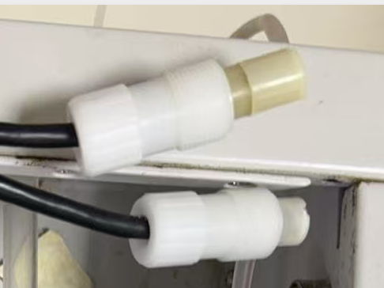

Figure 8, Enzyme Electrode Sensor

**1. Biochemical Recognition and Reaction:**

The sensor’s working electrode is immobilized with a specific enzyme membrane, such as lysine oxidase. When the target substrate (lysine) contacts the enzyme membrane, it undergoes a catalyzed oxidation reaction, which can be summarized as:

\text{赖氨酸} + O_2 + H_2O \rightarrow \alpha\text{-酮己二酸半醛} + NH_3 + H_2O_2

This reaction consumes oxygen and produces hydrogen peroxide (H₂O₂), providing the primary signal for subsequent electrochemical detection.

**2. Electrochemical Conversion and Signal Generation:**

The produced H₂O₂ diffuses to the electrode surface and undergoes oxidation under a constant anodic potential (typically +0.6 to +0.7 V vs. Ag/AgCl):

H_2O_2 \rightarrow O_2 + 2H^+ + 2e^-

This electron transfer generates a **small current**, the magnitude of which is **proportional to the H₂O₂ concentration**. Since the H₂O₂ concentration is directly determined by the enzymatic reaction rate, and the reaction rate is linearly proportional to the substrate concentration [S] within a certain range, the measured current can be considered a **direct reflection of the substrate concentration**.

**3．Quantitative Mathematical Model:**  
The dose-response relationship of the sensor can be described using a **Michaelis-Menten-type equation**:

I = \frac{I_\text{max} \times [S]}{K’_M + [S]}

where III is the steady-state current, I_\text{max}​ is the maximum saturation current, [S]is the substrate concentration, and K’ is the apparent Michaelis constant. In the low-concentration region ([S] \ll K’_M), this relationship can be approximated as linear:

I = k \times [S]

where *k* is the **sensor sensitivity coefficient**, ensuring that **trace levels of substrate can be accurately detected**.

**4.Signal Conditioning and Data Acquisition:**

Since the current generated by the electrochemical reaction is extremely weak (typically at the nA level), the system incorporates a transimpedance amplifier-based signal conditioning circuit to convert the microcurrent proportionally into a measurable voltage signal. The voltage signal is then digitized by the ADC embedded in the ESP32 main controller, enabling high-precision, real-time calculation of metabolite concentrations.

This workflow ensures efficient, reliable, and reproducible transduction from enzymatic reaction to digital output, providing a robust technical foundation for real-time monitoring of critical metabolites, such as lysine, during laboratory-scale fermentation processes.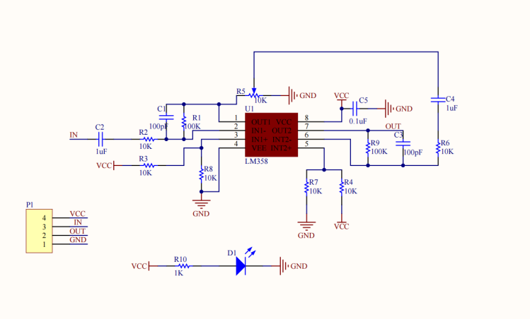

**Figure 9, Signal Conditioning Circuit of the Enzyme Electrode Sensor**

**1.4.2 Liquid Presence Sensor**

To enable **automated flow control and fail-safe monitoring**, a **low-cost, highly reliable liquid presence sensor** was developed in-house. The sensor functions as a **resistive detector**: in air, the resistance between the metal probes is effectively **infinite**, whereas when a liquid (aqueous solution) passes through, its **conductivity lowers the resistance** significantly, allowing detection of liquid presence.

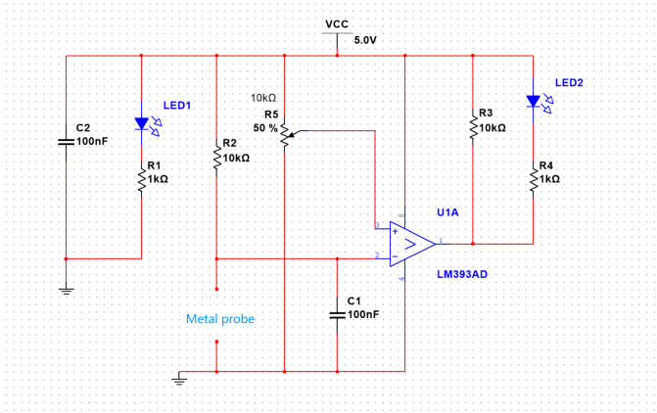

**Figure 10, Circuit of the Liquid Presence Sensor**

**Liquid Presence Sensor for Quantitative Sampling**

In the quantitative sampling process, the liquid presence sensor plays a critical role in level detection. During operation, the pump first draws liquid into the quantitative loop. Once the loop is filled, the sensor detects the presence of liquid, causing a significant change in the output signal, indicating that the liquid has reached the desired level. At this point, the system automatically switches the solenoid valve pathway, pumping the liquid out of the quantitative loop to achieve precise volumetric sampling.

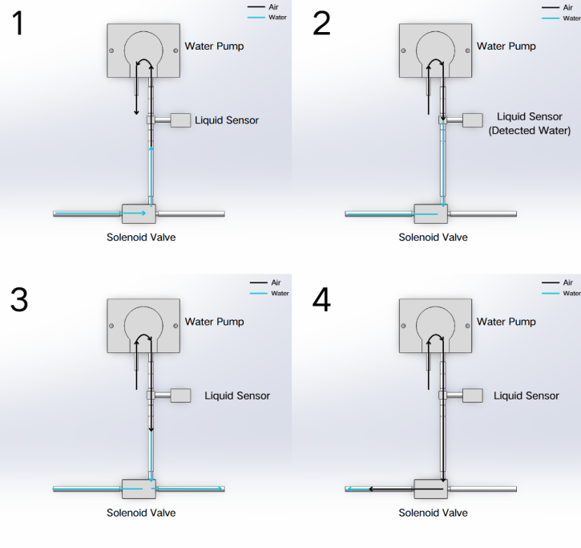

**Figure 11. Workflow of the Quantitative Loop**

The liquid presence sensor offers the advantages of low cost and rapid response. Additionally, the current passing through the sensor is extremely small, ensuring that it does not interfere with subsequent enzyme electrode measurements or other detection steps, thereby maintaining the stability and reliability of the entire automated sampling and analysis system.

**1.5 System Assembly and Overall Appearance**

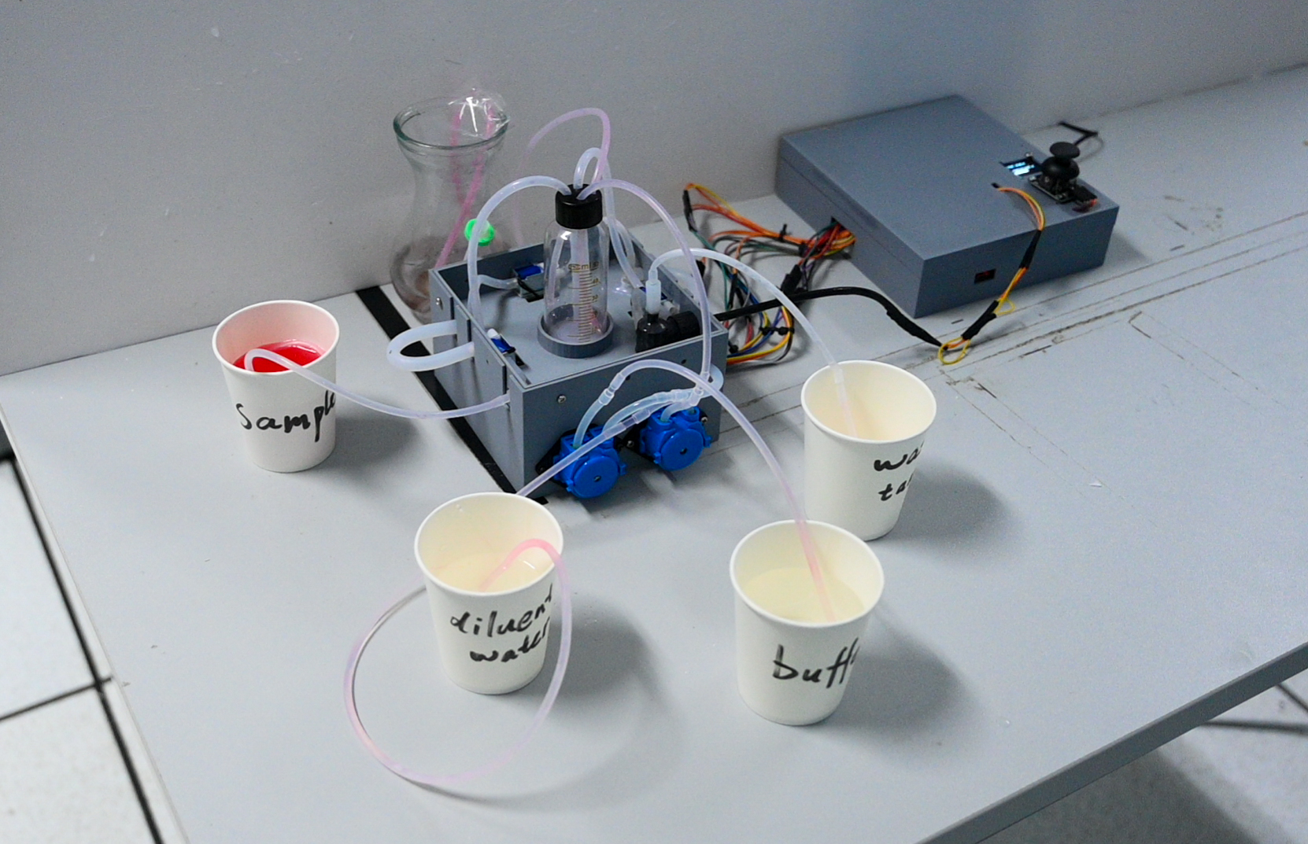

**Figure 12. Overall System Appearance**

**1.6 Hardware List**

|  |  |  |
| --- | --- | --- |
| Item List | Quantity | Cost (USD) |
| ESP32 microcontroller | 2 | 6 |
| OLED display (0.96’’ I2C) | 1 | 1 |
| Joystick module | 1 | 0.5 |
| Peristaltic pump (12 V) | 4 | 6 |
| Three-way solenoid valve | 3 | 5 |
| Power supply module (12 V / 5 V / 3.3 V)） | 1 | 3 |
| TB6612 motor driver | 4 | 3 |
| Liquid presence sensor | 3 | 1.2 |
| Signal conditioning circuit | 1 | 1.4 |
| DC motor (12 V) | 1 | 2 |
| Enzyme electrode sensor (glucose) | 1 | 20 |
| Three-way barbed connector (3.2 mm) | 3 | 0.15 |
| Two-way barbed connector | 2 | 0.2 |
| Tubing (3 mm) | —— | 3 |
| Breadboard | 2 | 1 |
| Custom 3D-printed enclosure | 1 | 10 |
| Miscellaneous (Dupont wires, heat shrink tubing, etc.) | 1 | 5 |
|  |  | 68.45 |

​​

**2. System Design and Workflow**

**​​ 2.1 Automated Workflow**

A **demonstration video** illustrates the stepwise operation of the automated sampling and analysis system

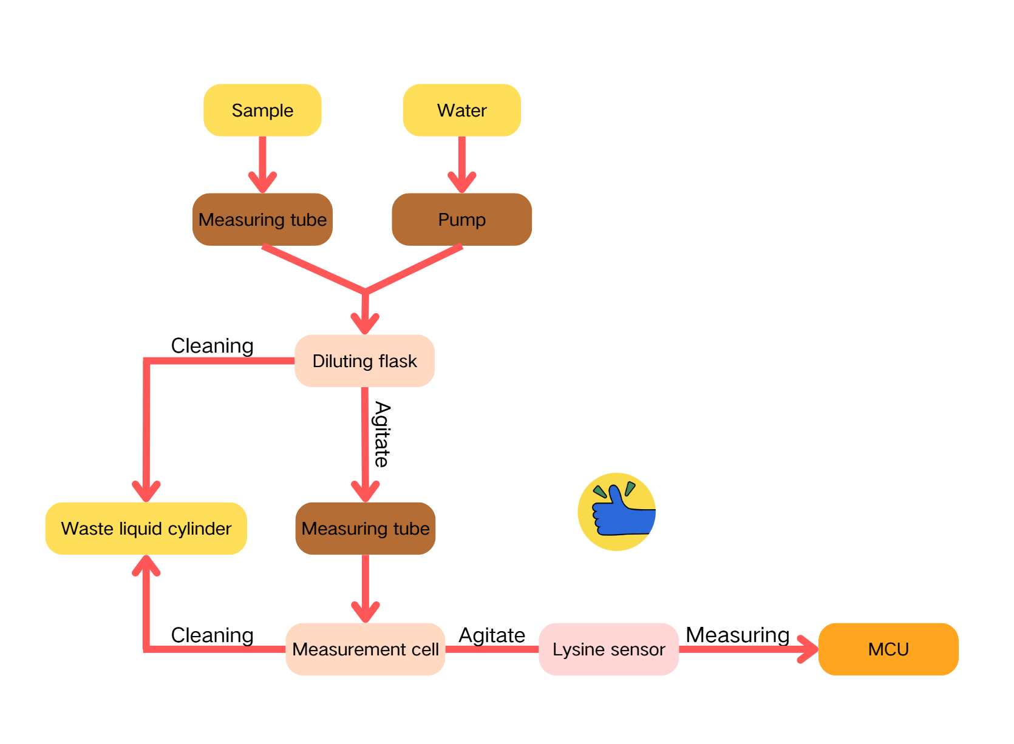

**Figure 13. System Workflow Diagram**

​​2.2 **Web-Based Real-Time Monitoring and Control System**

To enhance automation and visualization in our hardware module, we designed a Web-based real-time monitoring interface that enables seamless communication between the ESP32 controller and the computer. The system is built upon a local Node.js server, achieving bi-directional data exchange: commands can be sent from the computer to the ESP32, while the ESP32 reports back operational progress and simulated concentration data upon completing each step.

The front-end interface automatically retrieves and updates the latest experimental progress and concentration data in real time, providing users with a smooth and intuitive monitoring experience. Key features include:

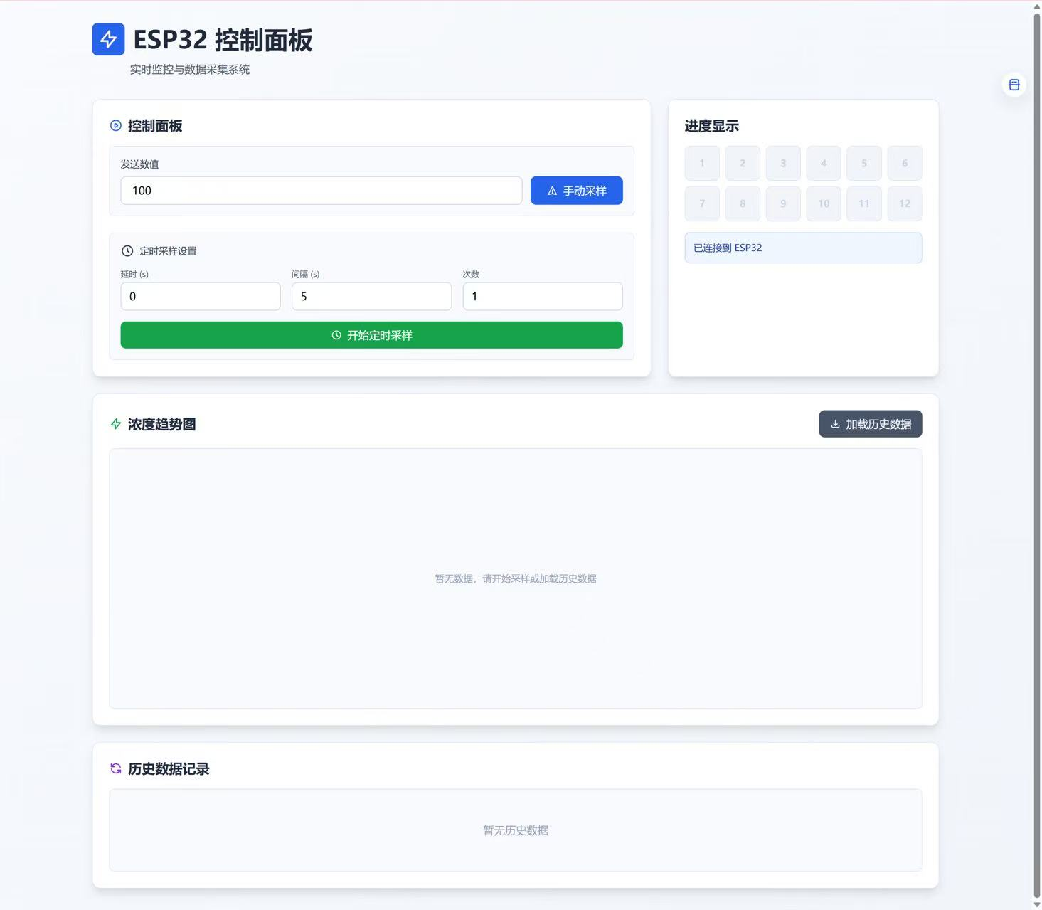

**Figure 14. Web-based User Interface**

1. **Real-time Step Display** ：The current experimental step is continuously updated and highlighted, ensuring clear visualization of progress.
2. **Dynamic Concentration Visualization** ：The interface automatically plots changes in simulated concentration, reflecting the ongoing reaction dynamics.
3. **Timed Sampling Control** ：Users can preset sampling intervals, starting time, and the number of sampling cycles, enabling automated and precise sampling operations.
4. **Lightweight Interaction Design** ：Built on a simple yet efficient WebSocket communication structure, the system maintains low latency and fast response, ideal for real-time monitoring scenarios.

This Web module provides a stable, intelligent, and user-friendly interface for the hardware automation system, making experimental monitoring and control both efficient and highly visualized.

​​​​

**3. Iterative Development**

The device underwent three generations of optimization:

1. First generation: validated the feasibility of hydraulic piston-based sampling.
2. Second generation: implemented a 3D-printed structure with automated sampling and remote control capabilities.
3. Third generation: integrated liquid presence sensors and peristaltic pumps, achieving a fully automated workflow for quantitative sampling, dilution, and real-time concentration measurement.

**3.1 Version 1**

During the initial iteration stage, a rudimentary first-generation device was designed and constructed to validate the feasibility of the proposed sampling approach. This version employed a hydraulically driven piston as the core sampling mechanism, with the piston stroke precisely controlled to regulate the volume of liquid intake, achieving quantitative sampling. The entire sampling process was manually operated and adjusted via a joystick to assess the device’s operational accuracy and reliability. This first-generation prototype provided foundational data and design experience, establishing a preliminary framework for improving automation and system stability in subsequent iterations.

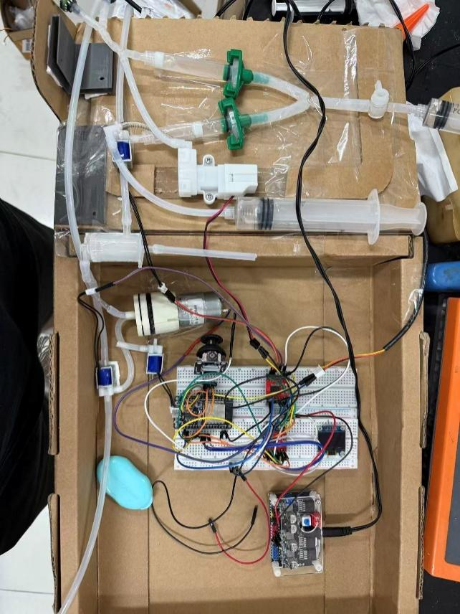

**Figure 15. Quantitative Sampling Device of Version 1**

**3.2 Version 2**

In the second iteration stage, the device structure was optimized by implementing a 3D-printed enclosure to reduce overall volume. Liquid pressure sensors were incorporated to enable precise control of the hydraulic drive, and optical sensors were added for real-time detection of liquid status, thereby improving the sampling control process and achieving automated sampling. Additionally, a web interface was developed to support remote manual sampling, scheduled quantitative sampling, and data visualization, enhancing the system’s intelligence, usability, and experimental efficiency.

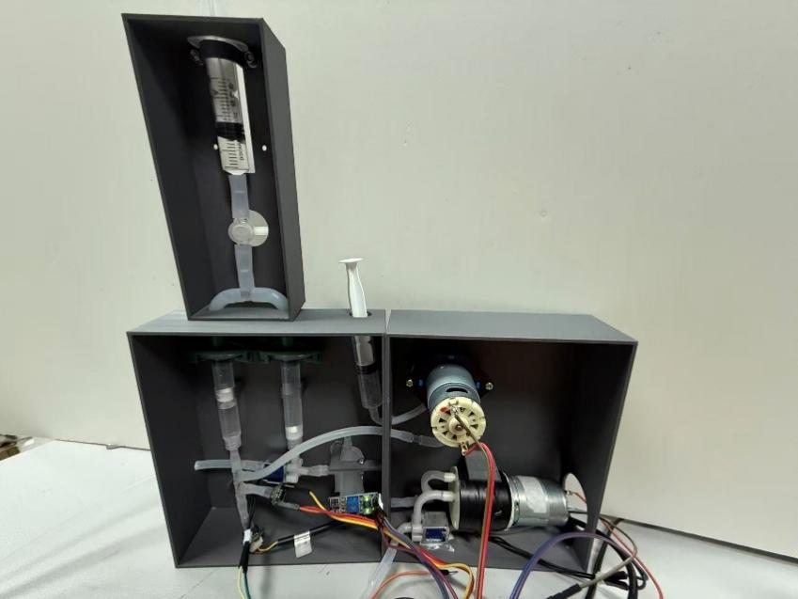

**Figure 16. Quantitative Sampling Device of Version 2**



**Figure 17. Workflow Diagram of Version 2 Device**

**3.3 Version 3**

In the third iteration, the piston-driven sampling mechanism was eliminated. A custom liquid presence sensor was developed, forming the basis for the quantitative loop structure described previously. Considering that centrifugal pumps are difficult to control precisely in terms of flow rate and volume, and pose risks of residual liquid and cross-contamination, peristaltic pumps were adopted instead. A reaction chamber was designed and validated via computational fluid dynamics (CFD) simulations. An enzyme electrode sensor was integrated for automatic concentration detection, and an OLED display was added to show real-time operation time and status. This version enables a complete automated workflow including quantitative sampling, dilution, and real-time metabolite concentration measurement.



**Figure 18. Complete Device of Version 3**

**4. System Evaluation and Future Outlook**

**4.1 Summary of System Advantages**

The automated sampling and detection system designed and implemented in this study demonstrates several significant advantages for real-time monitoring of lysine and glucose co-production fermentation:

High automation and remote control: The system, driven by an ESP32 microcontroller, enables fully automated workflows including scheduled sampling, filtration, dilution, mixing, and detection, greatly minimizing manual intervention. Coupled with Wi-Fi connectivity and a web interface, users can remotely configure parameters and monitor real-time data, substantially enhancing the convenience and controllability of the experimental process.

High Measurement Accuracy and Reproducibility: Precise volumetric sampling is achieved through the integration of the quantitative loop and highly reliable liquid presence sensors. The custom reaction chamber, with its optimized fluidic design, ensures rapid and homogeneous mixing of the sample and buffer. The enzyme electrode sensor module provides high specificity and sensitivity, guaranteeing accurate and consistent measurements.

Low Cost and Modular Design: Core sensors, such as the liquid presence sensor, are custom-fabricated, and key components utilize open-source hardware and general-purpose consumables, effectively controlling overall costs. The modular hardware architecture facilitates maintenance, upgrades, and adaptation to different analytical requirements.

High Adaptability and Ease of Deployment: The system’s compact structure and high automation level make it well-suited for long-term, continuous fermentation monitoring in laboratory settings, offering a reliable and economical solution to the low automation challenges in traditional biochemical assays.

**4.2 Limitations Analysis**  
Although the system performed well during testing, several limitations of the current version have been identified:

Environmental Adaptability: The system has been primarily operated in controlled laboratory conditions. Its long-term stability and reliability under more complex industrial environments—such as large temperature fluctuations, strong electromagnetic interference, or mechanical vibrations—remain to be validated.

Maintenance and Calibration Requirements: As the core sensitive component, the enzyme electrode sensor experiences gradual decay in enzyme membrane activity over time, necessitating regular calibration and replacement to maintain measurement accuracy. The current system does not yet include an automatic calibration function, requiring manual intervention.

Multi-Analyte Detection Capability: The present system is optimized primarily for lysine and glucose monitoring. To simultaneously monitor additional metabolites, such as cadaverine, the fluidic path and sensor configuration would need to be expanded, posing higher demands on the system’s integration and control logic.

**4.3 Optimization Directions and Future Prospects**  
Based on the current achievements and the above analysis, the system can be continuously optimized and upgraded in multiple directions. By integrating additional enzyme electrode sensors, it would be possible to simultaneously measure and analyze the concentrations of multiple metabolites from a single sample. Introducing cloud-based machine learning algorithms to model and analyze historical fermentation data could provide intelligent suggestions for problem diagnosis and process optimization. Selecting more corrosion-resistant and biocompatible materials (e.g., PEEK, PTFE) for critical fluidic components can enhance hardware reliability and minimize residual contamination. Designing a compact multi-channel fluidic system combined with a multi-electrode sensor array would enable parallel and continuous monitoring of multiple metabolites. Further structural optimization could achieve miniaturization and platformization, transforming the system into a portable and versatile online fermentation monitoring device, enhancing its adaptability for deployment across fermentation vessels of varying scales.

**5. References**

​